## The Main Menu

## Upon loading the index page, you will see a menu with four buttons. Press the play button to play the game, the Tutorial button to load the tutorial page *(not implemented yet), the Scoreboard button to go to the scoreboard, and the Credits button to go to the Credits screen.

## 

## The Game Screen

Upon entering the game, you will see a line of characters wearing a variety of colourful equipment. Note the labels, pause (red), player/game stats (blue), confirmation button (green), line movement/direction (purple). In addition consider the white box which will display your item selection.

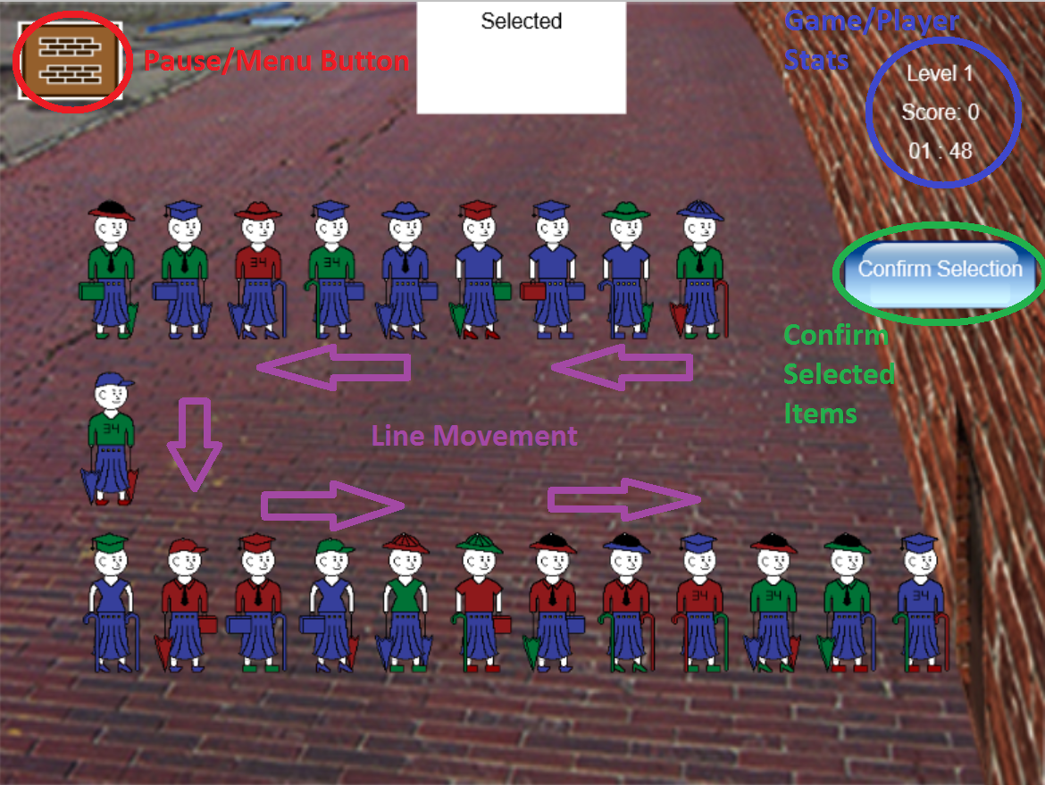

## Identify the Pattern

We need to identify the common item in order to proceed to the next district.

Notice how each person is wearing a **green shirt?**  
Let’s steal that shirt!  
**Click/Touch** on a person to enter their **item selection screen**

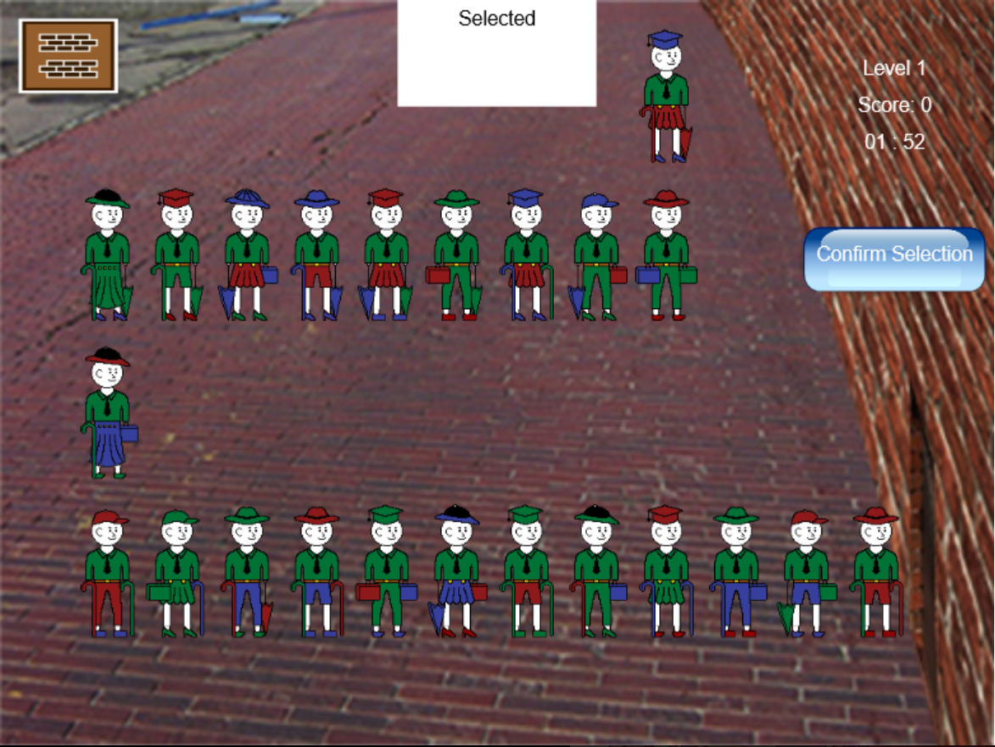

## Item Selection

After **clicking/touching** a person you will arrive at this screen.

Here, we have a boxes corresponding to each item type.

**Click/touch** the desired item you wish to steal… The **green shirt!**

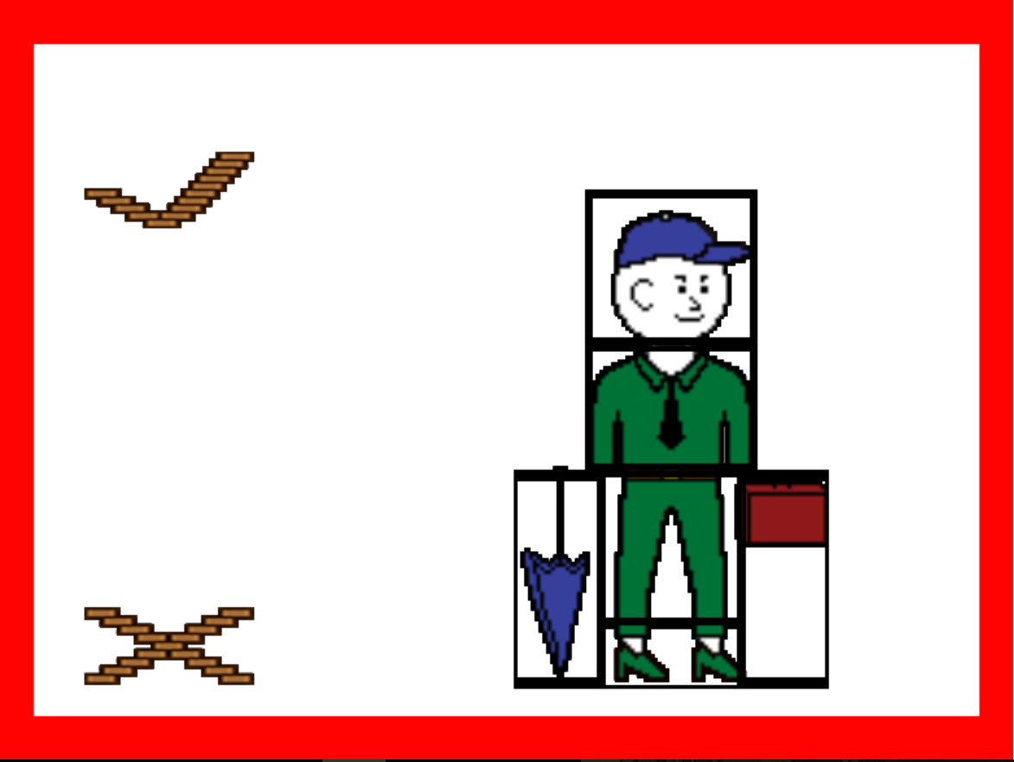

If you make a mistake, you can **click/touch** it again to go fix. Or you can hit the **X** button.

Once you select the shirt, **click/touch** the **checkmark** to confirm.

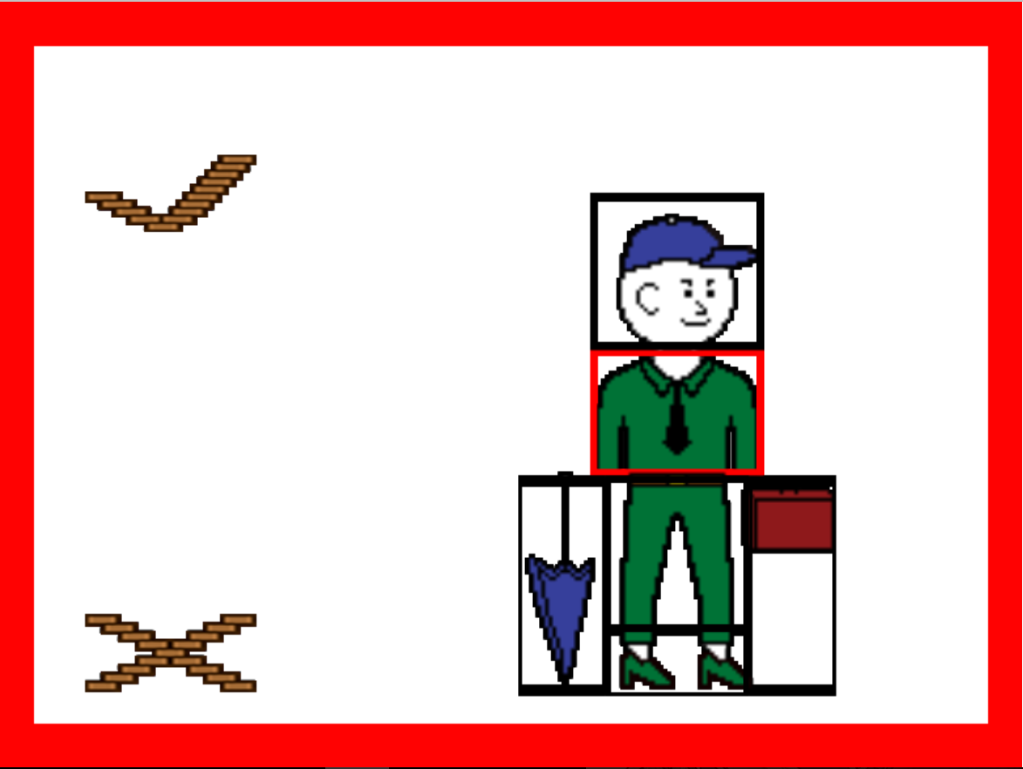

## Confirm Pattern

Once you’ve confirmed the item, you will return to the game screen.  
Double check your selection by comparing the item above (in the **white box**) to the people in the line. Once you’re absolutely sure, click the **confirm button** to either proceed to the next level. If you chose incorrectly, you will instead be directed to the Game Over screen.

Repeat this process until you escape district 34!!!

